**1. Creating hello world application.**

**Activity_main.xml**

*<?*xml version="1.0" encoding="utf-8"*?>*<androidx.constraintlayout.widget.ConstraintLayout xmlns:android="http://schemas.android.com/apk/res/android"  
 xmlns:app="http://schemas.android.com/apk/res-auto"  
 xmlns:tools="http://schemas.android.com/tools"  
 android:id="@+id/main"  
 android:layout_width="match_parent"  
 android:layout_height="match_parent"  
 android:background="#FFC107"  
 android:backgroundTint="#FFC107"  
 android:backgroundTintMode="src_atop"  
 tools:context=".MainActivity">  
  
 <TextView  
 android:layout_width="0dp"  
 android:layout_height="wrap_content"  
 android:layout_marginStart="24dp"  
 android:layout_marginBottom="32dp"  
 android:background="#FFEB3B"  
 android:backgroundTint="#2196F3"  
 android:backgroundTintMode="screen"  
 android:fontFamily="cursive"  
 android:rotationY="8"  
 android:text="Hello World..!"  
 android:textSize="100dp"  
 app:autoSizeTextType="uniform"  
 app:layout_constraintBottom_toBottomOf="parent"  
 app:layout_constraintEnd_toEndOf="parent"  
 app:layout_constraintHorizontal_bias="1.0"  
 app:layout_constraintStart_toStartOf="parent"  
 app:layout_constraintTop_toTopOf="parent"  
 app:layout_constraintVertical_bias="0.475" />  
  
</androidx.constraintlayout.widget.ConstraintLayout>

**MainActivity.java**

package com.example.a1prg;  
  
import android.os.Bundle;  
  
import androidx.activity.EdgeToEdge;  
import androidx.appcompat.app.AppCompatActivity;  
import androidx.core.graphics.Insets;  
import androidx.core.view.ViewCompat;  
import androidx.core.view.WindowInsetsCompat;  
  
public class MainActivity extends AppCompatActivity {  
  
 @Override  
 protected void onCreate(Bundle savedInstanceState) {  
 super.onCreate(savedInstanceState);  
 EdgeToEdge.*enable*(this);  
 setContentView(R.layout.*activity_main*);  
 ViewCompat.*setOnApplyWindowInsetsListener*(findViewById(R.id.*main*), (v, insets) -> {  
 Insets systemBars = insets.getInsets(WindowInsetsCompat.Type.*systemBars*());  
 v.setPadding(systemBars.left, systemBars.top, systemBars.right, systemBars.bottom);  
 return insets;  
 });  
 }  
}

**OUTPUT:**

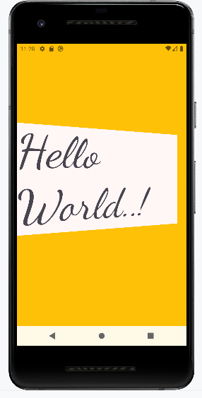 

**2. Create an application to develop login window using UI controls.**

**Activity_main.xml**

<?xml version="1.0" encoding="utf-8"?>  
<RelativeLayout xmlns:android="http://schemas.android.com/apk/res/android"  
 xmlns:app="http://schemas.android.com/apk/res-auto"  
 xmlns:tools="http://schemas.android.com/tools"  
 android:id="@+id/main"  
 android:layout_width="match_parent"  
 android:layout_height="match_parent"  
 tools:context=".MainActivity">  
  
 <LinearLayout  
 android:layout_width="match_parent"  
 android:layout_height="wrap_content"  
 android:gravity="center"  
 android:layout_centerInParent="true"  
 android:orientation="vertical"  
 android:padding="30dp">  
  
 <TextView  
 android:layout_width="wrap_content"  
 android:layout_height="wrap_content"  
 android:text="LoginPage"  
 android:textSize="32sp"  
 android:textStyle="bold"  
 android:fontFamily="sans-serif-condensed-medium"  
 android:textColor="@color/black"  
 android:paddingBottom="20dp" />  
  
 <EditText  
 android:id="@+id/editTextUsername"  
 android:layout_width="match_parent"  
 android:layout_height="wrap_content"  
 android:hint="Username"  
 android:layout_marginBottom="16dp"/>  
  
 <EditText  
 android:id="@+id/editTextPassword"  
 android:layout_width="match_parent"  
 android:layout_height="wrap_content"  
 android:hint="Password"  
 android:layout_below="@id/editTextUsername"  
 android:layout_marginBottom="16dp"  
 android:inputType="textPassword"/>

<Button  
 android:id="@+id/buttonLogin"  
 android:layout_width="wrap_content"  
 android:layout_height="wrap_content"  
 android:text="Login"  
 android:layout_below="@+id/editTextPassword"/>

</LinearLayout>  
</RelativeLayout>

**MainActivity.java**

package com.example.ashri2;  
  
import android.os.Bundle;  
  
import androidx.activity.EdgeToEdge;  
import androidx.appcompat.app.AppCompatActivity;  
import androidx.core.graphics.Insets;  
import androidx.core.view.ViewCompat;  
import androidx.core.view.WindowInsetsCompat;  
  
public class MainActivity extends AppCompatActivity {  
  
 @Override  
 protected void onCreate(Bundle savedInstanceState) {  
 super.onCreate(savedInstanceState);  
 EdgeToEdge.*enable*(this);  
 setContentView(R.layout.*activity_main*);  
 ViewCompat.*setOnApplyWindowInsetsListener*(findViewById(R.id.*main*), (v, insets) -> {  
 Insets systemBars = insets.getInsets(WindowInsetsCompat.Type.*systemBars*());  
 v.setPadding(systemBars.left, systemBars.top, systemBars.right, systemBars.bottom);  
 return insets;  
 });  
 }  
}

**OUTPUT:**

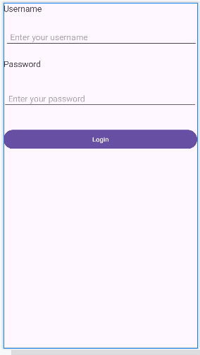

**3. Create an UI with all views**

**Activity_main.xml**

<?xml version="1.0" encoding="utf-8"?>  
<androidx.constraintlayout.widget.ConstraintLayout xmlns:android="http://schemas.android.com/apk/res/android"  
 xmlns:app="http://schemas.android.com/apk/res-auto"  
 xmlns:tools="http://schemas.android.com/tools"  
 android:id="@+id/main"  
 android:layout_width="match_parent"  
 android:layout_height="match_parent"  
 tools:context=".MainActivity">  
  
 <LinearLayout  
 android:layout_width="421dp"  
 android:layout_height="740dp"  
 android:orientation="vertical"  
 android:padding="16dp"  
 tools:layout_editor_absoluteX="-10dp">  
  
 <TextView  
 android:id="@+id/textView2"  
 android:layout_width="wrap_content"  
 android:layout_height="wrap_content"  
 android:layout_marginBottom="16dp"  
 android:text="This is a TextView"  
 android:textSize="18sp">

<Button  
 android:id="@+id/button"  
 android:layout_width="wrap_content"  
 android:layout_height="wrap_content"  
 android:layout_marginBottom="16dp"  
 android:layout_weight="1"  
 android:text="Click Me" />  
  
 <CheckBox  
 android:id="@+id/checkBox"  
 android:layout_width="wrap_content"  
 android:layout_height="wrap_content"  
 android:layout_marginBottom="16dp"  
 android:layout_weight="1"  
 android:text="Check Me" />  
  
 <RadioGroup  
 android:layout_width="wrap_content"  
 android:layout_height="wrap_content">  
 <RadioButton  
 android:id="@+id/radioButton1"  
 android:layout_width="wrap_content"  
 android:layout_height="wrap_content"  
 android:text="option 1" />  
  
 <RadioButton  
 android:id="@+id/radioButton2"  
 android:layout_width="wrap_content"  
 android:layout_height="wrap_content"  
 android:text="option 2" />  
 </RadioGroup>

<Switch  
 android:id="@+id/switch1"  
 android:layout_width="wrap_content"  
 android:layout_height="wrap_content"  
 android:layout_marginBottom="16dp"  
 android:text="Switch" />  
  
 <Spinner  
 android:id="@+id/spinner"  
 android:layout_width="match_parent"  
 android:layout_height="wrap_content"  
 android:layout_marginBottom="16dp" />  
  
 <ProgressBar  
 android:id="@+id/progressBar"  
 android:layout_width="wrap_content"  
 android:layout_height="wrap_content"  
 android:layout_marginBottom="16dp" />  
  
 <DatePicker  
 android:id="@+id/date_picker"  
 android:layout_width="374dp"  
 android:layout_height="315dp"  
 android:layout_marginBottom="16dp" />  
  
 <TimePicker  
 android:id="@+id/time_picker"  
 android:layout_width="wrap_content"  
 android:layout_height="wrap_content"  
 android:layout_marginBottom="16dp"/>  
  
 <NumberPicker  
 android:id="@+id/number_picker"  
 android:layout_width="wrap_content"  
 android:layout_height="wrap_content"  
 android:layout_marginBottom="16dp"/>  
 </LinearLayout>  
</androidx.constraintlayout.widget.ConstraintLayout>

**MainActivity.java**

package com.example.prg3;  
  
import android.os.Bundle;  
  
import androidx.activity.EdgeToEdge;  
import androidx.appcompat.app.AppCompatActivity;  
import androidx.core.graphics.Insets;  
import androidx.core.view.ViewCompat;  
import androidx.core.view.WindowInsetsCompat;  
  
public class MainActivity extends AppCompatActivity {  
  
 @Override  
 protected void onCreate(Bundle savedInstanceState) {  
 super.onCreate(savedInstanceState);  
 EdgeToEdge.*enable*(this);  
 setContentView(R.layout.*activity_main*);  
 ViewCompat.*setOnApplyWindowInsetsListener*(findViewById(R.id.*main*), (v, insets) -> {  
 Insets systemBars = insets.getInsets(WindowInsetsCompat.Type.*systemBars*());  
 v.setPadding(systemBars.left, systemBars.top, systemBars.right, systemBars.bottom);  
 return insets;  
 });  
 }  
}

**OUTPUT:**

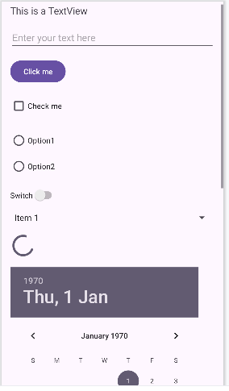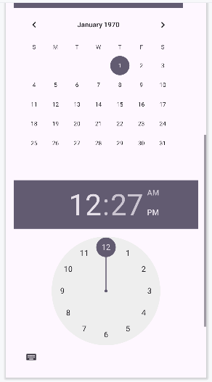

**4. Create a sample application with login module(Check user name and password) on successful login change TextView, “Login Successful”. On login fail alert using toast “login fail”.**

**Activity_main.xml**

*<?*xml version="1.0" encoding="utf-8"*?>*<RelativeLayout xmlns:android="http://schemas.android.com/apk/res/android"  
 android:layout_width="match_parent"  
 android:layout_height="match_parent"  
 android:padding="16dp">  
  
 <TextView  
 android:id="@+id/Label_username"  
 android:layout_width="wrap_content"  
 android:layout_height="wrap_content"  
 android:text="Username"  
 android:textSize="18sp"  
 android:layout_marginTop="50dp"  
 android:layout_centerHorizontal="true"/>  
  
 <EditText  
 android:id="@+id/input_username"  
 android:layout_width="match_parent"  
 android:layout_height="wrap_content"  
 android:hint="Enter your username"  
 android:layout_below="@+id/Label_username"  
 android:layout_marginTop="28dp"  
 android:padding="10dp"/>  
  
 <TextView  
 android:id="@+id/label_password"  
 android:layout_width="wrap_content"  
 android:layout_height="wrap_content"  
 android:text="Password"  
 android:textSize="18sp"  
 android:layout_below="@id/input_username"  
 android:layout_marginTop="20dp"  
 android:layout_centerHorizontal="true"/>  
  
 <EditText  
 android:id="@+id/input_password"  
 android:layout_width="match_parent"  
 android:layout_height="wrap_content"  
 android:hint="Enter your password"  
 android:inputType="textPassword"  
 android:layout_below="@id/label_password"  
 android:layout_marginTop="10dp"  
 android:padding="10dp"/>  
  
 <Button  
 android:id="@+id/button_login"  
 android:layout_width="match_parent"  
 android:layout_height="wrap_content"  
 android:text="Login"  
 android:layout_below="@id/input_password"  
 android:layout_marginTop="30dp"  
 android:padding="10dp"/>  
  
</RelativeLayout>

**MainActivity.java**

package com.example.program4;  
  
import android.os.Bundle;  
import android.text.TextUtils;  
import android.view.View;  
import android.widget.Button;  
import android.widget.EditText;  
import android.widget.Toast;  
import androidx.appcompat.app.AppCompatActivity;  
  
public class MainActivity extends AppCompatActivity {  
 private EditText inputUsername;  
 private EditText inputPassword;  
 private Button buttonLogin;  
  
  
 @Override  
 protected void onCreate(Bundle savedInstanceState) {  
 super.onCreate(savedInstanceState);  
 setContentView(R.layout.*activity_main*);  
  
 inputUsername = findViewById(R.id.*input_username*);  
 inputPassword = findViewById(R.id.*input_password*);  
 buttonLogin = findViewById(R.id.*button_login*);  
 buttonLogin.setOnClickListener(new View.OnClickListener() {  
 @Override  
 public void onClick(View v) {  
 validateLogin();  
 }  
 });  
  
 }  
  
 private void validateLogin() {  
 String username = inputUsername.getText().toString().trim();  
 String password = inputPassword.getText().toString().trim();  
 if (TextUtils.*isEmpty*(username) || TextUtils.*isEmpty*(password)) {  
 Toast.*makeText*(this, "username and password cannot be empty", Toast.*LENGTH_SHORT*).show();  
  
 } else {  
 if (username.equals("admin") && password.equals("1234")) {  
 Toast.*makeText*(this, "Login successful", Toast.*LENGTH_SHORT*).show();  
  
 } else {  
 Toast.*makeText*(this, "Login fail", Toast.*LENGTH_SHORT*).show();  
 }  
 }  
  
 }  
}

**OUTPUT:**

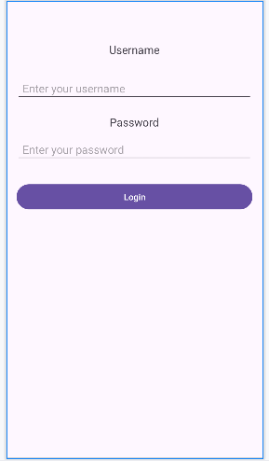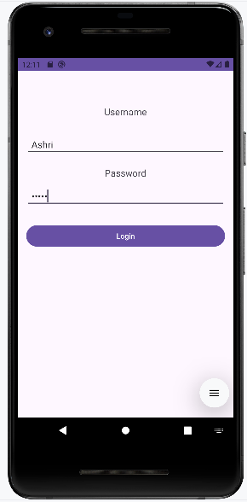

**5. CREATING AN APPLICATION THAT DISPLAYS MESSAGE BASED ON THE SCREEN ORIENTATION**.

**androidManifest.xml:**

*<?*xml version="1.0" encoding="utf-8"*?>*<manifest xmlns:android="http://schemas.android.com/apk/res/android"  
 xmlns:tools="http://schemas.android.com/tools" >  
  
 <application  
 android:allowBackup="true"  
 android:dataExtractionRules="@xml/data_extraction_rules"  
 android:fullBackupContent="@xml/backup_rules"  
 android:icon="@mipmap/ic_launcher"  
 android:label="@string/app_name"  
 android:roundIcon="@mipmap/ic_launcher_round"  
 android:supportsRtl="true"  
 android:theme="@style/Theme.ScreenPrg"  
 tools:targetApi="31" >  
 <activity  
 android:name=".activity_main3"  
 android:exported="false" />  
 <activity  
 android:name=".MainActivity3"  
 android:exported="false"  
 android:screenOrientation="landscape" />  
 <activity  
 android:name=".MainActivity"  
 android:exported="true"  
 android:screenOrientation="portrait" >  
 <intent-filter>  
 <action android:name="android.intent.action.MAIN" />  
  
 <category android:name="android.intent.category.LAUNCHER" />  
 </intent-filter>  
 </activity>  
 </application>  
  
</manifest>

**Activity_main.xml:**

*<?*xml version="1.0" encoding="utf-8"*?>*<androidx.constraintlayout.widget.ConstraintLayout  
 xmlns:android="http://schemas.android.com/apk/res/android"  
 xmlns:app="http://schemas.android.com/apk/res-auto"  
 xmlns:tools="http://schemas.android.com/tools"  
 android:id="@+id/main"  
 android:layout_width="match_parent"  
 android:layout_height="match_parent"  
 tools:context=".MainActivity">  
  
 <Button  
 android:id="@+id/button2"  
 android:layout_width="wrap_content"  
 android:layout_height="wrap_content"  
 android:layout_marginBottom="8dp"  
 android:layout_marginTop="112dp"  
 android:onClick="onClick"  
  
 android:text="Launch next activity"  
 app:layout_constraintBottom_toBottomOf="parent"  
 app:layout_constraintEnd_toEndOf="parent"  
 app:layout_constraintHorizontal_bias="0.612"  
 app:layout_constraintTop_toBottomOf="@+id/editText1"  
 app:layout_constraintVertical_bias="0.613" />  
  
 <TextView  
 android:id="@+id/editText1"  
 android:layout_width="wrap_content"  
 android:layout_height="wrap_content"  
 android:layout_centerHorizontal="true"  
 android:layout_marginEnd="8dp"  
 android:layout_marginTop="124dp"  
 android:layout_marginStart="8dp"  
 android:ems="10"  
 android:textSize="22dp"  
 android:text="This activity is portrait orientation"  
 app:layout_constraintEnd_toEndOf="parent"  
 app:layout_constraintHorizontal_bias="0.502"  
 app:layout_constraintStart_toStartOf="parent"  
 app:layout_constraintTop_toTopOf="parent" />  
</androidx.constraintlayout.widget.ConstraintLayout>

**MainActivity.java:**

package com.example.screenprg;  
  
import android.os.Bundle;  
  
import androidx.activity.EdgeToEdge;  
import androidx.appcompat.app.AppCompatActivity;  
import androidx.core.graphics.Insets;  
import androidx.core.view.ViewCompat;  
import androidx.core.view.WindowInsetsCompat;  
import android.content.Intent;  
import android.view.View;  
  
public class MainActivity extends AppCompatActivity {  
  
 @Override  
 protected void onCreate(Bundle savedInstanceState) {  
 super.onCreate(savedInstanceState);  
 EdgeToEdge.*enable*(this);  
 setContentView(R.layout.*activity_main*);  
 ViewCompat.*setOnApplyWindowInsetsListener*(findViewById(R.id.*main*), (v, insets) -> {  
 Insets systemBars = insets.getInsets(WindowInsetsCompat.Type.*systemBars*());  
 v.setPadding(systemBars.left, systemBars.top, systemBars.right, systemBars.bottom);  
 return insets;  
 });  
 }  
 public void onClick(View v)  
 {  
 Intent intent = new Intent(MainActivity.this,MainActivity3.class);  
 startActivity(intent);  
  
 }  
}

**activity_main3.xml:**

*<?*xml version="1.0" encoding="utf-8"*?>*<androidx.constraintlayout.widget.ConstraintLayout xmlns:android="http://schemas.android.com/apk/res/android"  
 xmlns:app="http://schemas.android.com/apk/res-auto"  
 xmlns:tools="http://schemas.android.com/tools"  
 android:id="@+id/main"  
 android:layout_width="match_parent"  
 android:layout_height="match_parent"  
 tools:context=".MainActivity3">  
  
 <TextView  
 android:id="@+id/textView"  
 android:layout_width="wrap_content"  
 android:layout_height="wrap_content"  
 android:layout_marginEnd="8dp"  
 android:layout_marginStart="8dp"  
 android:text="This is landscape Orientation"  
 android:textSize="22dp"  
 app:layout_constraintEnd_toEndOf="parent"  
 app:layout_constraintHorizontal_bias="0.502"  
 app:layout_constraintStart_toStartOf="parent"  
 app:layout_constraintTop_toTopOf="parent" />  
</androidx.constraintlayout.widget.ConstraintLayout>

**MainActivity3.java:**

package com.example.screenprg;  
  
import android.os.Bundle;  
  
import androidx.activity.EdgeToEdge;  
import androidx.appcompat.app.AppCompatActivity;  
import androidx.core.graphics.Insets;  
import androidx.core.view.ViewCompat;  
import androidx.core.view.WindowInsetsCompat;  
  
public class MainActivity3 extends AppCompatActivity {  
  
 @Override  
 protected void onCreate(Bundle savedInstanceState) {  
 super.onCreate(savedInstanceState);  
 EdgeToEdge.*enable*(this);  
 setContentView(R.layout.*activity_main3*);  
 ViewCompat.*setOnApplyWindowInsetsListener*(findViewById(R.id.*main*), (v, insets) -> {  
 Insets systemBars = insets.getInsets(WindowInsetsCompat.Type.*systemBars*());  
 v.setPadding(systemBars.left, systemBars.top, systemBars.right, systemBars.bottom);  
 return insets;  
 });  
 }  
}

**OUTPUT:**

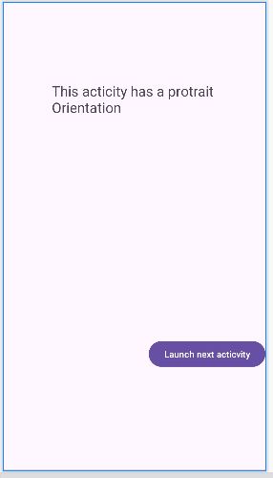 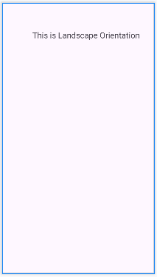

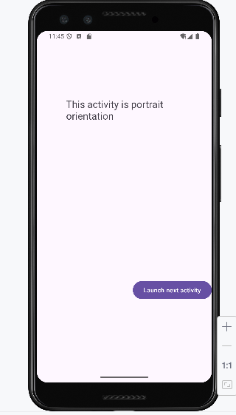 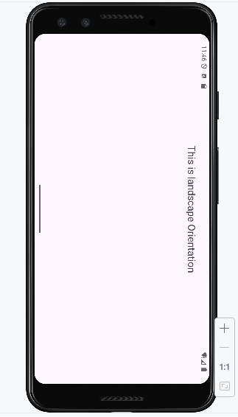

**6. CREATE AN APPLICATION TO IMPLEMENT NEW ACTIVITY USING EXPLICIT INTENT AND IMPLICIT INTENT**.

**Activity_mani.xml:**

*<?*xml version="1.0" encoding="utf-8"*?>* <LinearLayout xmlns:android="http://schemas.android.com/apk/res/android"  
 xmlns:app="http://schemas.android.com/apk/res-auto"  
 xmlns:tools="http://schemas.android.com/tools"  
 android:id="@+id/main"  
 android:layout_width="match_parent"  
 android:layout_height="match_parent"  
 tools:context=".MainActivity"  
 android:orientation="vertical"  
 android:padding="30dp">  
  
 <Button  
 android:id="@+id/btnExplicitContent"  
 android:layout_width="match_parent"  
 android:layout_height="wrap_content"  
 android:text="Explicit Content"  
 android:textSize="30sp"  
 android:layout_marginTop="30dp">  
  
 </Button>  
</LinearLayout>

**Mainactivity.java:**

package com.example.implicitandexplicit;  
import androidx.appcompat.app.AppCompatActivity;  
import android.content.Intent;  
import android.os.Bundle;  
import android.view.View;  
import android.widget.Button;  
  
public class MainActivity extends AppCompatActivity {  
  
 Button btnExplicitContent;  
 @Override  
 protected void onCreate(Bundle savedInstanceState) {  
 super.onCreate(savedInstanceState);  
 setContentView(R.layout.*activity_main*);  
 btnExplicitContent = findViewById(R.id.*btnExplicitContent*);  
 btnExplicitContent.setOnClickListener(new View.OnClickListener() {  
 @Override  
 public void onClick(View view) {  
 Intent intent = new Intent(MainActivity.this,  
 MainActivity2.class);  
 startActivity(intent);  
 }  
 });  
 }  
}

**activity_main2.xml:**

*<?*xml version="1.0" encoding="utf-8"*?>*<LinearLayout xmlns:android="http://schemas.android.com/apk/res/android"  
 xmlns:app="http://schemas.android.com/apk/res-auto"  
 xmlns:tools="http://schemas.android.com/tools"  
 android:id="@+id/main"  
 android:layout_width="match_parent"  
 android:layout_height="match_parent"  
 tools:context=".MainActivity2"  
 android:orientation="vertical"  
 android:padding="30dp">  
  
 <Button  
 android:id="@+id/btnImplicitContent"  
 android:layout_width="match_parent"  
 android:layout_height="wrap_content"  
 android:text="Implicit Content"  
 android:textSize="30sp"  
 android:layout_marginTop="30dp">  
  
 </Button>  
</LinearLayout>

**mainActivity2.java:**

package com.example.implicitandexplicit;  
  
import androidx.appcompat.app.AppCompatActivity;  
import android.content.Intent;  
import android.net.Uri;  
import android.os.Bundle;  
import android.view.View;  
import android.widget.Button;  
  
public class MainActivity2 extends AppCompatActivity  
{  
 Button btnImplicitContent;  
 @Override  
 protected void onCreate(Bundle savedInstanceState)  
 {  
 super.onCreate(savedInstanceState);  
 setContentView(R.layout.*activity_main*);  
 btnImplicitContent = findViewById(R.id.*btnImplicitContent*);  
 btnImplicitContent.setOnClickListener(new View.OnClickListener()  
 {  
 @Override  
 public void onClick(View view)  
 {  
 Uri webpage=Uri.*parse*("https://www.google.com");  
 Intent intent = new Intent(Intent.*ACTION_VIEW*, webpage);  
 startActivity(intent);  
 }  
 });  
 }  
}

**OUTPUT:**

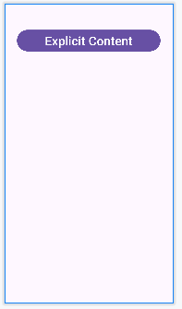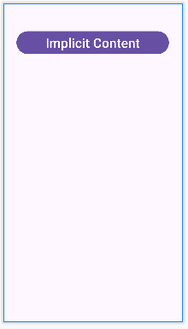

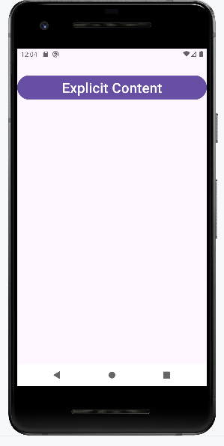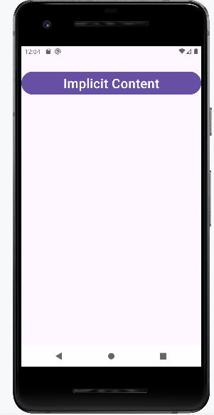

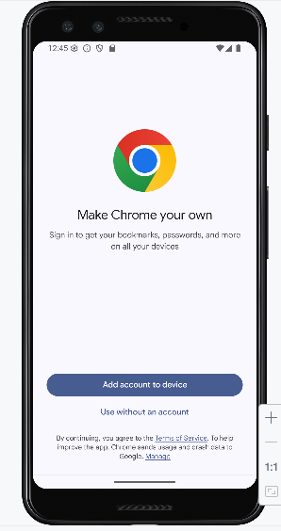

**7. CREATE AN APPLICATION THAT DISPLAYS CUSTOM DESIGNED OPENING SCREEN.**

**Custom_background.xml:**

*<?*xml version="1.0" encoding="utf-8"*?>*<shape xmlns:android="http://schemas.android.com/apk/res/android"  
 android:shape="rectangle">  
 <gradient  
 android:startColor="#3F51B5"  
 android:endColor="#2196F3"  
 android:angle="45"/>  
'</shape>

**Activity_main.xml:**

*<?*xml version="1.0" encoding="utf-8"*?>*<RelativeLayout xmlns:android="http://schemas.android.com/apk/res/android"  
 xmlns:app="http://schemas.android.com/apk/res-auto"  
 xmlns:tools="http://schemas.android.com/tools"  
 android:id="@+id/main"  
 android:layout_width="match_parent"  
 android:layout_height="match_parent"  
 tools:context=".MainActivity"  
 android:background="@drawable/custom_background">  
  
 <TextView  
 android:id="@+id/textView"  
 android:layout_width="wrap_content"  
 android:layout_height="wrap_content"  
 android:text="Welcome to App"  
 android:textSize="50sp"  
 android:layout_centerInParent="true"/>  
</RelativeLayout>

**MainActivity.java:**

package com.example.drawableprg;  
  
import androidx.appcompat.app.AppCompatActivity;  
import android.content.Intent;  
import android.os.Bundle;  
import android.os.Handler;  
import android.view.Window;  
import android.view.WindowManager;  
  
public class MainActivity extends AppCompatActivity {  
  
 @Override  
 protected void onCreate(Bundle savedInstanceState) {  
 super.onCreate(savedInstanceState);  
 requestWindowFeature(Window.*FEATURE_NO_TITLE*);  
 getWindow().setFlags(WindowManager.LayoutParams.*FLAG_FULLSCREEN*,  
 WindowManager.LayoutParams.*FLAG_FULLSCREEN*);  
 setContentView(R.layout.*activity_main*);  
 Handler handler = new Handler();  
 handler.postDelayed(new Runnable() {  
 @Override  
 public void run() {  
 Intent intent = new  
 Intent(MainActivity.this, MainActivity2.class);  
 startActivity(intent);  
 finish();  
 }  
 }, 50000);  
 }  
}

**OUTPUT:**

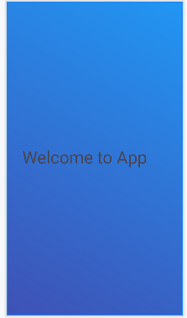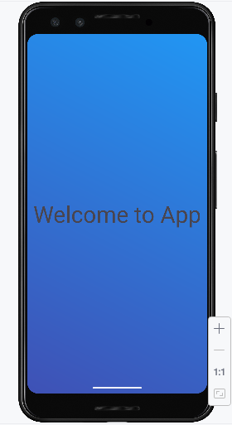

**8. READ/WRITE THE LOCAL DATA.**

**Activity_main.xml:**

*<?*xml version="1.0" encoding="utf-8"*?>*<LinearLayout xmlns:android="http://schemas.android.com/apk/res/android"  
 xmlns:app="http://schemas.android.com/apk/res-auto"  
 xmlns:tools="http://schemas.android.com/tools"  
 android:layout_width="match_parent"  
 android:layout_height="match_parent"  
 tools:context=".MainActivity2"  
 android:orientation="vertical">  
  
  
 <Button  
 android:id="@+id/btnFetch"  
 android:layout_width="wrap_content"  
 android:layout_height="wrap_content"  
 android:text="Fetch" />  
  
 <TextView  
 android:layout_width="match_parent"  
 android:layout_height="wrap_content"  
 android:text="User Name">  
 </TextView>  
  
 <EditText  
 android:id="@+id/etUserName"  
 android:layout_width="match_parent"  
 android:layout_height="wrap_content">  
 </EditText>  
  
 <TextView  
 android:layout_width="match_parent"  
 android:layout_height="wrap_content"  
 android:text="Password">  
 </TextView>  
  
 <EditText  
 android:id="@+id/etPassword"  
 android:layout_width="match_parent"  
 android:layout_height="wrap_content">  
 </EditText>  
</LinearLayout>

**MainActivity.java:**

package com.example.localprg;  
  
import androidx.appcompat.app.AppCompatActivity;  
import android.content.Context;  
import android.content.Intent;  
import android.content.SharedPreferences;  
import android.os.Bundle;  
import android.view.View;  
import android.widget.Button;  
import android.widget.EditText;  
import android.widget.Toast;  
  
public class MainActivity extends AppCompatActivity {  
 Button btnsave,btnnext;  
 EditText etUserName,etPassword;  
  
 @Override  
 protected void onCreate(Bundle savedInstanceState) {  
 super.onCreate(savedInstanceState);  
 setContentView(R.layout.*activity_main*);  
 btnsave = (Button) findViewById(R.id.*btnsave*);  
 btnnext = (Button) findViewById(R.id.*btnnext*);  
 etUserName = (EditText) findViewById(R.id.*etUserName*);  
 etPassword = (EditText) findViewById(R.id.*etPassword*);  
 btnsave.setOnClickListener(new View.OnClickListener() {  
 @Override  
 public void onClick(View view) {  
 SharedPreferences sharedPreferences = getSharedPreferences("MyPrefs", Context.*MODE_PRIVATE*);  
 SharedPreferences.Editor editor = sharedPreferences.edit();  
 editor.putString("username", etUserName.getText().toString());  
 editor.putString("password", etPassword.getText().toString());  
 editor.apply();  
 Toast.*makeText*(getApplicationContext(), "Saved successfully", Toast.*LENGTH_LONG*).show();  
 }  
 });  
 btnsave.setOnClickListener(new View.OnClickListener() {  
 @Override  
 public void onClick(View view) {  
 Intent intent = new Intent(getApplicationContext(), MainActivity.class);  
 startActivity(intent);  
 }  
 });  
 }  
}

**activity_main2.xml:**

*<?*xml version="1.0" encoding="utf-8"*?>*<LinearLayout xmlns:android="http://schemas.android.com/apk/res/android"  
 xmlns:app="http://schemas.android.com/apk/res-auto"  
 xmlns:tools="http://schemas.android.com/tools"  
 android:layout_width="match_parent"  
 android:layout_height="match_parent"  
 tools:context=".MainActivity2"  
 android:orientation="vertical">  
  
  
 <Button  
 android:id="@+id/btnFetch"  
 android:layout_width="wrap_content"  
 android:layout_height="wrap_content"  
 android:text="Fetch" />  
  
 <TextView  
 android:layout_width="match_parent"  
 android:layout_height="wrap_content"  
 android:text="User Name">  
 </TextView>  
  
 <EditText  
 android:id="@+id/etUserName"  
 android:layout_width="match_parent"  
 android:layout_height="wrap_content">  
 </EditText>  
  
 <TextView  
 android:layout_width="match_parent"  
 android:layout_height="wrap_content"  
 android:text="Password">  
 </TextView>  
  
 <EditText  
 android:id="@+id/etPassword"  
 android:layout_width="match_parent"  
 android:layout_height="wrap_content">  
 </EditText>  
</LinearLayout>

**mainActivity2.java:**

package com.example.localprg;  
  
import androidx.appcompat.app.AppCompatActivity;  
import android.content.Context;  
import android.content.SharedPreferences;  
import android.os.Bundle;  
import android.view.View;  
import android.widget.Button;  
import android.widget.EditText;  
  
public class MainActivity2 extends AppCompatActivity {  
 Button btnFetch;  
 EditText etUserName, etPassword;  
  
 @Override  
 protected void onCreate(Bundle savedInstanceState) {  
 super.onCreate(savedInstanceState);  
 setContentView(R.layout.*activity_main4*);  
 btnFetch = (Button) findViewById(R.id.*btnFetch*);  
 etUserName = (EditText) findViewById(R.id.*etUserName*);  
 etPassword = (EditText) findViewById(R.id.*etPassword*);  
 btnFetch.setOnClickListener(new View.OnClickListener() {  
 @Override  
 public void onClick(View view) {  
 SharedPreferences sharedPreferences = getSharedPreferences("MyPrefs", Context.*MODE_PRIVATE*);  
 String username = sharedPreferences.getString("username", "");  
 String password = sharedPreferences.getString("password", "");  
 etUserName.setText(username);  
 etPassword.setText(password);  
 }  
 });  
 }  
}

**OUTPUT:**

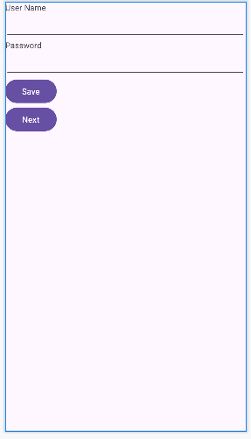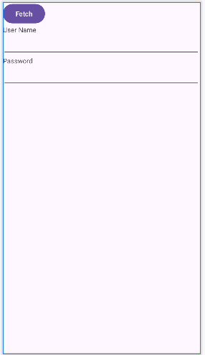

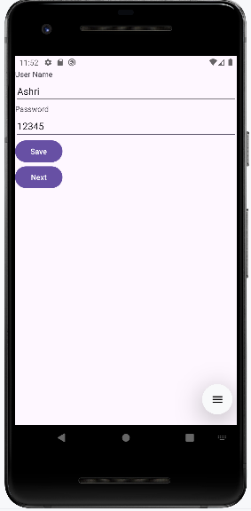 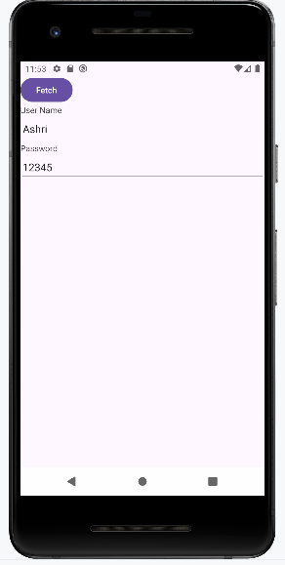

**9. LEARN TO DISPLAY ANDROID APPLICATIONS.**

**Activity_main.xml:**

*<?*xml version="1.0" encoding="utf-8"*?>*<androidx.constraintlayout.widget.ConstraintLayout xmlns:android="http://schemas.android.com/apk/res/android"  
 xmlns:app="http://schemas.android.com/apk/res-auto"  
 xmlns:tools="http://schemas.android.com/tools"  
 android:layout_width="match_parent"  
 android:layout_height="match_parent"  
 tools:context=".MainActivity">  
  
 <TextView  
 android:layout_width="wrap_content"  
 android:layout_height="wrap_content"  
 android:text="Hello World!"  
 app:layout_constraintBottom_toBottomOf="parent"  
 app:layout_constraintEnd_toEndOf="parent"  
 app:layout_constraintStart_toStartOf="parent"  
 app:layout_constraintTop_toTopOf="parent"  
 android:textSize="30sp"/>  
  
</androidx.constraintlayout.widget.ConstraintLayout>

**mainActivity.java:**

package com.example.android;  
  
import androidx.appcompat.app.AppCompatActivity;  
import android.os.Bundle;  
  
public class MainActivity extends AppCompatActivity  
{  
 protected void onCreate(Bundle savedInstanceState)  
 {  
 super.onCreate(savedInstanceState);  
 setContentView(R.layout.*activity_main*);  
 }  
}

**OUTPUT:**

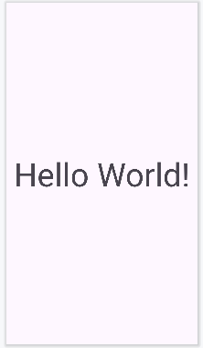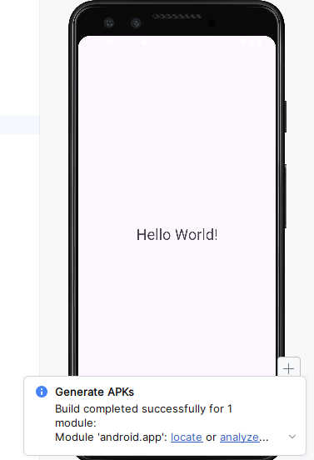

**10. CREATE AN APPLICATION TO SEND AN EMAIL.**

**Activity_main.xml:**

*<?*xml version="1.0" encoding="utf-8"*?>* <RelativeLayout xmlns:android="http://schemas.android.com/apk/res/android"  
 xmlns:app="http://schemas.android.com/apk/res-auto"  
 xmlns:tools="http://schemas.android.com/tools"  
 android:layout_width="match_parent"  
 android:layout_height="match_parent"  
 tools:context=".MainActivity">  
  
  
 <EditText  
 android:id="@+id/editTextTo"  
 android:layout_width="match_parent"  
 android:layout_height="wrap_content"  
 android:text="To" />  
  
 <EditText  
 android:id="@+id/editTextSubject"  
 android:layout_width="match_parent"  
 android:layout_height="wrap_content"  
 android:layout_below="@+id/editTextTo"  
 android:hint="Subject" />  
  
 <EditText  
 android:id="@+id/editTextMessage"  
 android:layout_width="match_parent"  
 android:layout_height="wrap_content"  
 android:layout_below="@+id/editTextSubject"  
 android:hint="Message" />  
  
 <Button  
 android:id="@+id/buttonSend"  
 android:layout_width="wrap_content"  
 android:layout_height="wrap_content"  
 android:layout_below="@+id/editTextMessage"  
 android:text="Send"/>  
</RelativeLayout>

**MainActivity.java:**

package com.example.email;  
import androidx.appcompat.app.AppCompatActivity;  
import android.annotation.SuppressLint;  
import android.content.Intent;  
import android.os.Bundle;  
import android.view.View;  
import android.widget.Button;  
import android.widget.EditText;  
public class MainActivity extends AppCompatActivity  
{  
 EditText editTextTo,editTextSubject,editTextMessage;  
 Button buttonSend;  
 @Override  
 protected void onCreate(Bundle savedInstanceState)  
 {  
 super.onCreate(savedInstanceState);  
 setContentView(R.layout.*activity_main*);  
 editTextTo=findViewById(R.id.*editTextTo*);  
 editTextSubject=findViewById(R.id.*editTextSubject*);  
 editTextMessage=findViewById(R.id.*editTextMessage*);  
 buttonSend=findViewById(R.id.*buttonSend*);  
 buttonSend.setOnClickListener(new View.OnClickListener() {  
 @Override  
 public void onClick(View v)  
 {  
 sendEmail();  
 }  
 });  
 }  
 @SuppressLint("QueryPermissionsNeeded")  
 private void sendEmail()  
 {  
 String to=editTextTo.getText().toString().trim();  
 String subject=editTextSubject.getText().toString().trim();  
 String message=editTextMessage.getText().toString().trim();  
 Intent intent= new Intent(Intent.*ACTION_SEND*);  
 intent.setType("text/plain");  
 intent.putExtra(Intent.*EXTRA_EMAIL*,new String[]{to});  
 intent.putExtra(Intent.*EXTRA_SUBJECT*,subject);  
 intent.putExtra(Intent.*EXTRA_TEXT*,message);  
 if(intent.resolveActivity(getPackageManager())!=null)  
 {  
 startActivity(Intent.*createChooser*(intent,"Choose an email client"));  
 }  
  
 }  
}

**OUTPUT:**

